

**VIETNAMESE STUDY SYSTEM FOR JAPANESE**

**Report #1 – Project Introduction**

**Project Code: Veazy**

**Document Code: Veazy_Introduction_EN**

CONTENT

1 CONTENT 2

2 INTRODUCTION 3

2.1 Purpose 3

2.2 Acronyms and Definition 3

3 ABSTRACT 3

4 LITERATURE REVIEW 3

5 PROPOSAL 5

5.1 The idea 5

5.2 Objectives 6

5.3 Brief description about system 6

5.4 System’s features 6

6 BENEFIT FROM PROJECT 7

6.1 For development team 7

6.2 For community 7

7 CRITICAL ASSUMPTIONS AND CONSTRAINTS 8

7.1 Assumption 8

7.2 Constraints 8

8 POTENTIAL RISKS 8

9 REFERENCES 9

# INTRODUCTION

## Purpose

This is the Software Requirement Specification (SRS) for the Vietnamese Study System for Japanese (Veazy). The purpose of this document is to convey information about:

1. Background overview & literature review of similar existing system.
2. Brief introduction about the initial idea for Veazy.
3. Main features of Veazy.
4. Constraints and potential risks of the project.

## Acronyms and Definition

|  |  |
| --- | --- |
| **Acronyms & Abbreviations** | **Definition** |
| SRS | Software Requirements Specification |
| IT | Information Technology |
| JS | JavaScript |
| FU | FPT University |
| CP | Capstone Project |
| SQL | Structured Query Language |

Table . Acronyms and Abbreviations

# ABSTRACT

Vietnam is ranked as one of the top 10 nations that attract foreign labor candidates. In order to adapt to new living and working environment, a lot of foreign people who stay and work in Vietnam have high need in studying Vietnamese as a second language.

However, because Vietnam is not seen by media as economic powerhouse, thus, in comparison with English or Japanese, Vietnamese is far from becoming a common language all over the world. Along with its complexity and unclear curriculum structure, Vietnamese causes many difficult to learners, especially those who struggle learning by themselves. Besides, due to working schedules, many people find it difficult to afford their time to enroll a Vietnamese course at the language centers.

Aiming at foreign people working in Vietnam, in particular, Japanese people and those who have interest in Vietnamese as well and striving to achieve the objective of helping users study Vietnamese in an easy and convenient way, the website is expected to solve all limitation above.

# LITERATURE REVIEW

Although Vietnamese is not ranked as one of the most common languages, there still are websites and mobile applications that support users in studying Vietnamese. Each of them has their own unique traits as well as advantages and disadvantages. These following are some typical examples of existing systems which team members carried out analysis:

**123vietnamese.com**

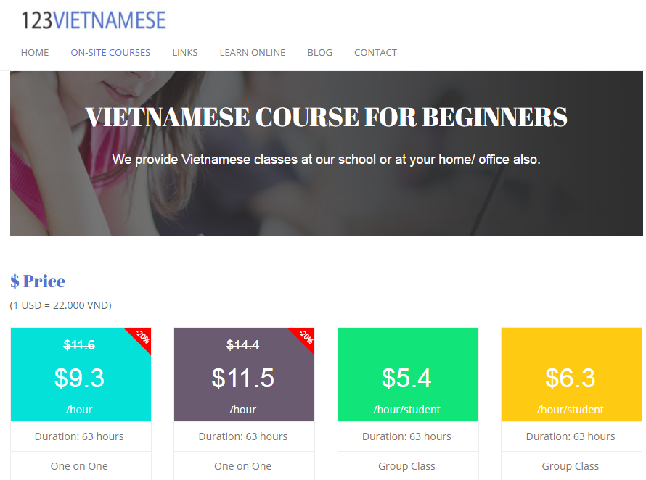

Figure . 123Vietnamese

123VIETNAMESE is a Vietnamese language training center that was founded in 2010 by a teacher group from Hanoi University of Education and University of Languages & International Studies.

* Advantages:
* The website supports user in studying through video call with lecture, which is flexible in time for students.
* The diverse online lessons are classified based on level of difficulty and purposes (for academy, research or travelling).
* Disadvantages:
* The website charges course fee.

**l-lingo.com**

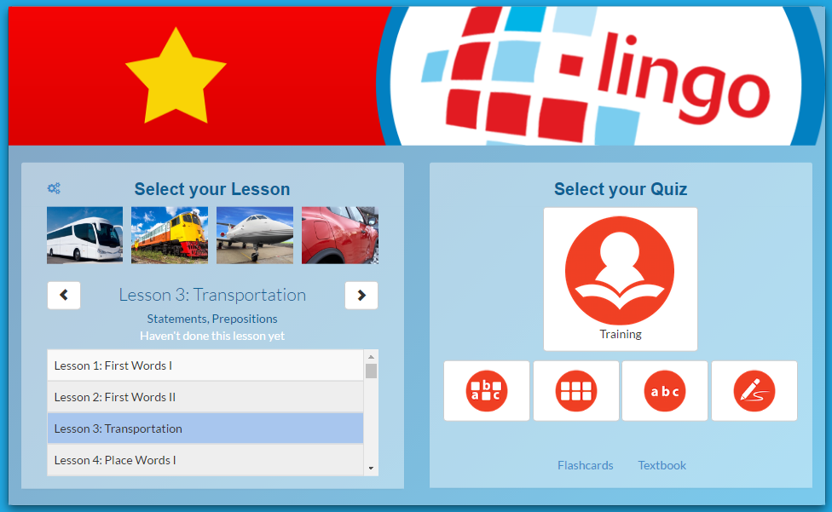

Figure . l-lingo

l-lingo is a website helping users study 20 Asian & European languages including Vietnamese.

* + - * Advantages:
* The themes of lessons are very diverse.
* The website uses words, images and sound clips of native speakers, which is very convenient for users to study vocabulary and practice listening.
* The website including quiz section at each lesson to help user review.
  + - * Disadvantages:
* The website focuses mostly on teaching vocabulary related to themes. There is no grammar section in each lesson.
* The number of free lessons is limited. User have to register and log in in order to continue studying.

# PROPOSAL

## The idea

Currently, there are lots of applications supporting foreign people to study Vietnamese which diversifies from websites to mobile applications. Still, after having analyzed carefully some of existing systems, team members have found out several disadvantages listed above.

The idea of Veazy is to overcome those limitations by creating a free website for studying Vietnamese, in which our team keeps original basic features such as lessons, small tests while including convenient features for users as well as features adapting to changes in study course’s structure.

## Objectives

Capstone Project (CP) is the final subject included in study program of FPT University (FU). There are 4 main objectives of a CP.

The first and foremost objective of this project is to *achieve the objective which project team set at the beginning*: to release a website supporting users in study Vietnamese. The second object is that this CP serves as a *standard* for CP Council to *decide whether development team is qualified to graduate or not*. The third objective of CP is to help students *review all knowledge related to IT technique and IT project management* studied through 4 years in university. During project management process, students learn how to apply these knowledge and make decision in order to lead the project to success. The fourth objective is to help students *acquire self-study skill through making research* about programming languages and popular frameworks for the need of projects which are not included as a part of the university study program.

## Brief description about system

This software is a web application which offers users almost of main features without registration. The website help users enlarge knowledge about Vietnamese including grammar, vocabulary through activities such as studying by lesson, reading articles and looking up dictionary, taking test corresponding to each skill and level of difficulty. User can send feedback to admin about the contents of the website. After logging in the system, user can see their progress of study and skills accessments.

Veazy uses familiar technologies such as Java, JavaScript, HTML, SQL Server and supports the most used browser like Internet Explorer, Firefox or Chrome.

## System’s features

Veazy’s features are divided into 4 different categories based on types of users:

* **Features for ordinary users**:
* ***Study* *Vietnamese***: Users can select and enroll in an appropriate course of Vietnamese divided into 6 levels of difficulty. Each lesson contains 6 sections of content: vocabulary, grammar, conversation, listening, practice and reading.
* ***Take Vietnamese tests***: Users can take multiple choice test based on difficulty level and type of skill which user can select.
* ***Report content***: User can send report about the contents of lessons and test questions.
* ***Look up in dictionary***: Users can search for words’ meanings and related examples in both Vietnamese-Japanese and Japanese-Vietnamese dictionary.
* ***View statistics (only available after login)****:* Users can display charts representing current progress of study, assessment on each respective skill.
* ***Log in/Log out***: Users can log into Veazy system with a registered account for more unique futures. Users can register new account or choose to log in by using Facebook or Google account.
* ***Change password/Recover password***: Users can change password when necessary or request to update a new one in case of forgetting the current password.
* **Extra features for content editors**:
* ***Review*** ***report***: Admins & content creators can check the reports or feedbacks sent by users.
* ***Manage*** ***lesson*** ***contents***: Content creators can view list of lessons in each course, create, edit content and delete a lesson.
* ***Manage test question contents***: Content creators can view list of questions, create, edit content and delete a question.
* **Extra features for admins**:
* ***Manage*** ***users***: Admins can view list of accounts as well as each respective account’s detail information, assign authority (admin or content creator) to any account, ban/unban an account.

# BENEFIT FROM PROJECT

## For development team

All members in development team gain more experience in each following field:

* **IT Project management**: Team members understand all phases of project management as well as individual responsibility, what needs to achieve, what needs to deliver during an IT project.
* **Programming** **languages**: Front-end developers gain more experience in HTML&CSS, JavaScript while back-end developers gains more experience in Java and SQL-Server.
* **Soft skills**: Each member learns to become a team player who can communicate effectively and know how to delegate and assign tasks to appropriate members as well as support each other.
* **Natural languages**: Team members have the chance to make research about Vietnamese and Japanese at a certain level of depth, which enrich members’ knowledge. Members also get to realize and correct inaccurate ways of speaking and writing Vietnamese which are often mistaken.

## For community

All Internet users have more resources and channel which are free of charge and allow:

* Studying Vietnamese grammar and vocabulary through online courses.
* Keeping track of study progress and current ability.
* Enhancing reading ability as well as knowledge through reading articles about Vietnam.
* Taking test corresponding to level of difficulty.
* Taking advantage of Vietnamese-Japanese dictionary during learning process.

# CRITICAL ASSUMPTIONS AND CONSTRAINTS

## Assumption

An assumption is a circumstance or event that need to occur for the project to be successful, but are out of range project team can control. These following are circumstances assumed to occur in project:

* Devices used to store data of project are well preserved.
* When a team member becomes sick, there is another members who can take over and continue his or her tasks without delaying project progress.
* Team members are able to use new technologies need for the project after 3 weeks of training.
* Team members are able to devote full 6 hours per day for project commitment.
* Team members can communicate well with each other.

## Constraints

A constraint, in project management, is any restriction that defines a project’s limitation. These following are project constraints defined by team members and classified into categories:

* **Time**: The length of project is 4 months (from May to August, 2016). Project must be delivered and ready for demo before the due date of August 25th.
* **Resources**:
* Team scales is limited to 6 people who are all junior software developer.
* Team members spend at least 6 hours per day for the project.
* **Quality**:
* The website should operate well on popular web browsers such as Internet Explorer (version 9.0 above), Firefox (version 40.0 above) and Google Chrome (version 45.0 above).
* The website should provide full features listed at part 4.4.

# POTENTIAL RISKS

Project risk is an uncertain event or condition which has an effect on project objective if it occurs. These following are project risks identified which might have the possibility to happen:

* + - * **Problem in project** **management**: team member might miss the product delivery deadline or fail to keep track of progress according to project plan due to limited experience.
      * **Problem in new technologies**: team members spends only about 3 weeks for training in new technology, thus, they might still encounter trouble during development process.
      * **Constant** **changes** **in** **requirement**: constant changes in software requirements can make team member fail to keep track and induce the possibility of failing to complete the project on time.
      * **Illness**: If a member falls ill and have no choice but to take some days off for recovery, their own tasks is delayed, which might affect other team members’ tasks as well.
      * **Lacking of time**: Team members might not spend enough time and commitment for project due to factors such as study schedule, pressure caused by exams at university, daily commutation.
      * **ThecomplexityofVietnamese**: Vietnamese is ranked as one of the most difficult language. Its difficulty might cause difficulty for building contents of lessons as well as course structure.
      * **Data** **loss**: Hardware failure of devices resulted from reasons such as collisions or overheat might cause data loss. Computer viruses might cause damage to files. Last but not least, there is also a possibility that team members accidentally delete files due to carelessness.
      * **Memberconflict**: Conflicts between members caused by misunderstanding during communication or being unable to reach a consensus can affect teamwork, which decreases productivity.

# REFERENCES

[1] [www.123vietnamese.com](http://www.123vietnamese.com)

[2] [www.l-lingo.com](http://www.l-lingo.com)